⚙️ Document: Integration for Notification & Message Dropdowns in Your E2EE Platform
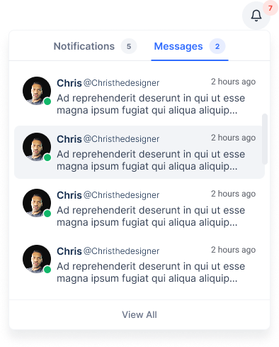

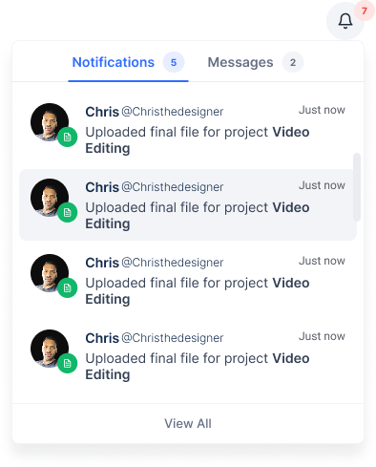
🚀 Purpose of this dropdown
This dropdown is a hybrid alert center inside your app’s header (or side nav), showing two critical but separate flows:
- Notifications tab:
  - Shows system-level events that your backend safely knows in plaintext.
  - Examples:
    - “John uploaded invoice.pdf to Project X.”
    - “Your contract with DesignLab starts tomorrow.”
- Messages tab:
  - Shows encrypted conversation previews, which must be decrypted on the client (browser).
  - Examples:
    - “Anna: Hey, here’s the final design!”
    - “Project Lead: Let’s review tomorrow.”
Together they let your users:
✅ See real-time team activity.
✅ Quickly preview direct & group chats.
✅ Maintain full privacy guarantees (your backend never sees decrypted message text).

🔍 Functional architecture
🔔 Notifications | 💬 Messages
Pulled from your DB directly. | Pulled as ciphertext from API or Ably.
Already in safe plaintext (no content risk). | Decrypted in-browser using private key stored in IndexedDB.
Examples: file uploads, milestone comments, project state changes. | Examples: user-to-user messages, group conversations.

🏗 How the dropdown works
- When user opens the dropdown:
  - Loads last 10 notifications via /api/notifications.
  - Loads last 10 message records (ciphertexts) via /api/messages.
- Client decrypts message ciphertexts locally using their private key from IndexedDB.
- Displays message sender & snippet just like a normal messaging app.

🔐 Why it’s critical for E2EE
- Even though you show snippets inside the dropdown, your server only stores or transmits ciphertext.
- The decryption only happens in the user’s browser, using their local private key.
- Ensures your platform still fulfills the marketing promise:
“We can’t read your messages — only you and your team can.”

🚀 Example implementation details

🔌 1. Notifications (plaintext)

📈 Typical API
GET /api/notifications?limit=10
Returns:
[
{
"type": "file_upload",
"actorName": "John",
"projectName": "Project X",
"createdAt": "2025-06-23T15:12:00Z"
},
{
"type": "contract_start",
"projectName": "DesignLab",
"startDate": "2025-06-25"
}
]
Rendered with simple text:
- John uploaded invoice.pdf to Project X
- Your contract with DesignLab starts on June 25

🔐 2. Messages (E2EE snippet preview)

📈 Typical API
GET /api/messages/recent?limit=10
Returns ciphertext only:
[
{
"conversationId": "conv-123",
"senderId": "user-456",
"senderName": "Anna",
"ciphertext": "AOI8Gz39D13..."
}
]


🔄 3. Browser decrypt & render
import { decryptMessage } from "@/crypto/e2ee";
import { loadPrivateKey } from "@/crypto/indexedDb";

async function loadMessages() {
const privateKey = await loadPrivateKey(currentUserId);
const res = await fetch('/api/messages/recent?limit=10');
const encryptedMessages = await res.json();

const decrypted = await Promise.all(
encryptedMessages.map(async (msg) => ({
...msg,
snippet: await decryptMessage(msg.ciphertext, privateKey)
}))
);

setMessages(decrypted);
}
✅ Now you can safely show:
Anna: Hey, here’s the final design!
in the dropdown — decrypted only inside the browser.

📣 UX summary for designers
- Notifications tab: shows project & system updates, styled in your clean muted system colors.
- Messages tab: shows name + decrypted snippet + small timestamp.
- Clicking a message drops you into /chat/:conversationId with the full conversation loaded (decrypted client-side).

🛡 Key security guarantees
🔥 | What this gives you
✅ Notifications are safe to generate on server. | Because they’re already known project events.
✅ Message content never decrypted server-side. | Only user’s browser decrypts with private key.
✅ Even dropdown snippet is decrypted on device. | Fulfills your E2EE marketing & compliance promises.

